**Test for Connected graph:**

1. **Test passed but not connected graph:**

import org.junit.After;

import org.junit.AfterClass;

import org.junit.Before;

import org.junit.BeforeClass;

import org.junit.Test;

import static org.junit.Assert.*;

public class ConnectedGraphTest {

public ConnectedGraphTest() { }

public static void setUpClass() { }

public static void tearDownClass() { }

public void setUp() { }

public void tearDown() { }

public void testDfs() {

System.out.println("dfs");

int[][] matrix = {{0,1,0},{1,0,0},{0,0,0}};

int source = 1;

ConnectedGraph instance = new ConnectedGraph();

String testres = instance.dfs(matrix, source);

String res1="is connected";

String res2="not connected";

if(res1.equals(testres))

{

System.out.println("pass the test");

} else if(res2.equals(testres)){

System.out.println("passed the test");

}

else {

fail("No expected result");

} } }

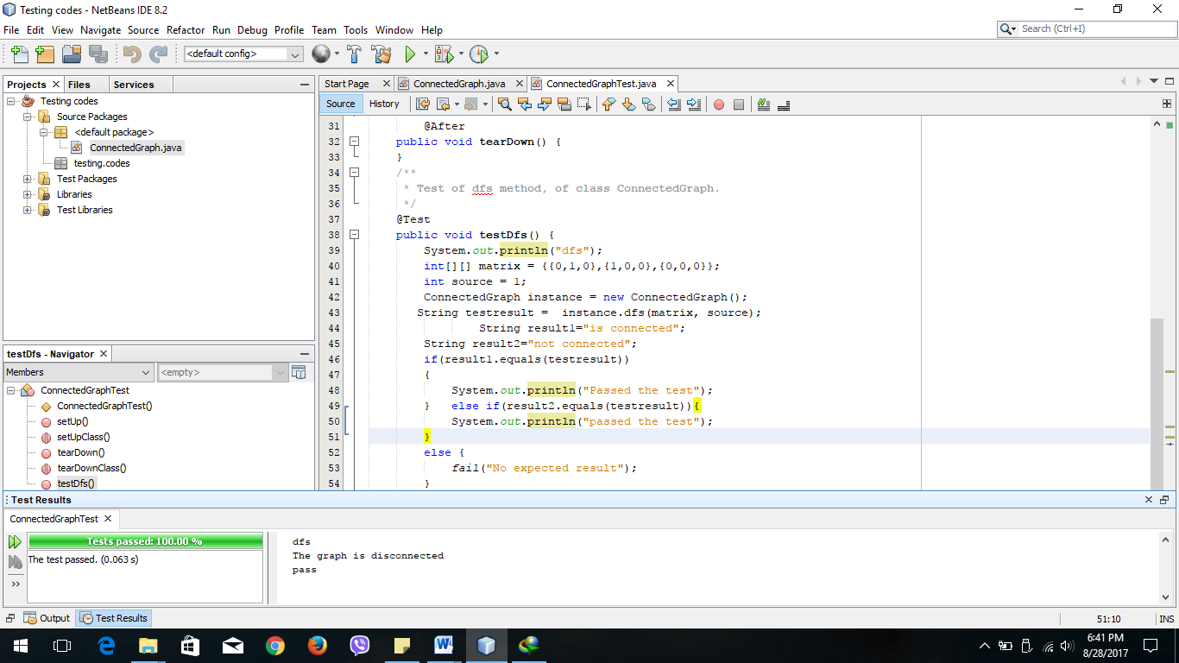

Here the provided matrix is of a graph which is not connected and the program has shown the same. The test based on this has showed as that the program has successfully passed the test.

1. **Test passed and the graph is connected as well.**

On the above test program matrix of a connected graph is provided. The provided matrix here was

int[][] matrix = {{0,1,1},{1,0,1},{1,1,0}};

Here the program has shown the same that the graph is connected. The test based on this has showed as that the program has successfully passed the test.

